Lela Z. Hamilton
12/11/2025
Workshop: Crafting Effective Questions and Hypotheses

Scenario 1: Retail Sales Analysis> you work for a retail company that has noticed a decline in sales during specific months. Your goal is to understand the factors contributing to this decline and formulate actionable insights to improve sales performance.
- Open-ended questions:
  - Where are the customers buying behaviors in other demographics that show increase sales during slow months?
  - What are some competitors’ campaigns that would have an impact towards a decline?
  - What staff changes occurred that contributed to slow sales? And did this contribute to poor customer service?
  - What are the holiday/seasonal months in which customers are buying more? And highest sales in those demographics
- Hypothesis
  - The store sales declined during slow months because of poor customer service satisfaction and low staff availability causing customers to shift their buying power to their competitors.
Scenario 2: Healthcare Patient Satisfaction > You are part of a healthcare organization aiming to enhance patient satisfaction. You want to identify areas where patient experiences could be improved
- Closed-ended questions:
  - Did your provider answer all your questions?
  - Did you get a follow up?
  - We’re you satisfied with your front office visit?
  - Did you feel safe during your vaccination?
  - We’re you seen within the appointment time frame?
- Hypothesis
  - Shorter waiting times and clear understanding of visit summary could have positive feedback scores compared to other healthcare providers in near demographics

Scenario 3: Social Media Engagement> A social media platform seeks to understand factors affecting user engagement with its app. Your objective is to uncover insights that can boost user interaction and retention.
- Open-ended question that delves into user preferences and behaviors:
  - Does the app have stricter security privacy compared to other competitor apps?
  - Does the app offer a wide range of product availability to reach larger target audiences?
  - Does the app widgets promote user engagement easily?
- Hypothesis
  - By using advance technologies in products and services can boost social media engagement and increase user retention.

Scenario 4: Environmental Conservation> An environmental organization aims to reduce plastic waste in a coastal area. You want to identify key locations where plastic waste accumulates the most.

- Closed-ended question to gather data on plastic waste accumulation in different areas.
  - Does seasonal months have impacted the most?
  - Does the organization outsource its sampling testing or use internal resources?
  - Are there any oil/gas manufacturing nearby?
Hypothesis:
  - By evaluating and sampling areas of high human and industrial activity, the organization and pinpoint locations where plastic waste is accumulating significantly.

Approach Summary
Context: After completing the tasks for the above scenarios, create a summary answering the following questions:
- How did you approach the task of crafting effective questions?
  - Researched internet articles based on factual data outcomes
- What challenges did you face in formulating testable hypotheses?
  - Limiting the hypotheses so that it’s not too broad in scope
- How might your questions and hypotheses evolve as you gather initial data?
  - Making sure I obtain legit data from a variety of surveys methods
- What additional information would have been helpful in refining your approach?
  - Articles from research studies to validate data
- How could your questions and hypotheses lead to actionable business insights?
  - Improving customer satisfaction percentages
  - Improving profit margins by developing new marketing campaigns like competitors’
  - Thinking outside the box to come up with solutions that weren’t previously known
  - Implementing and optimizing training and development systems for staffing

Assignment # 2: Introduction to Python - Practice Exercise
NOTES:
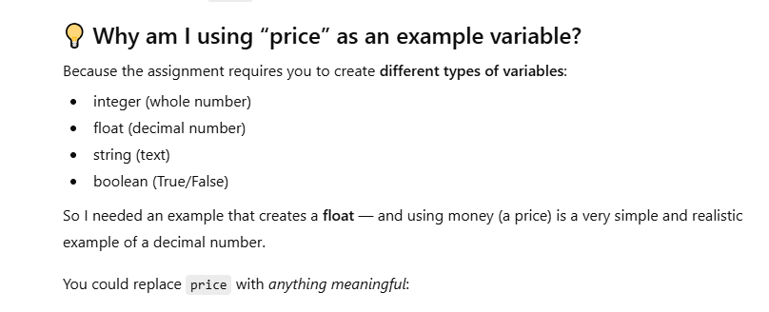
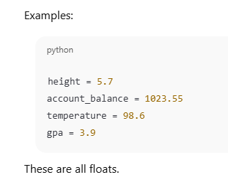

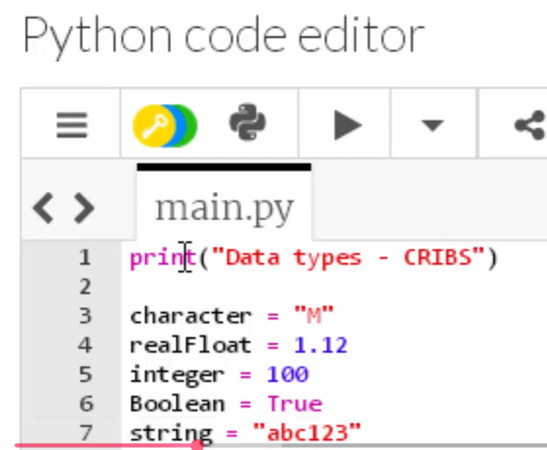
Remember Tip**** when using Arithmetic in “print….” Use the (shift + Ent) >means RUN

Open Ended vs Closed Ended
      - Open Ended > can not say yes or no can lead to many open possibilities
      - Closed Ended> Yes or No (always add a ? mark at end)

